Computer Network Security

Computer network security consists of measures taken by business or some organizations to monitor and prevent unauthorized access from the outside attackers.

Different approaches to computer network security management have different requirements depending on the size of the computer network. For example, a home office requires basic network security while large businesses require high maintenance to prevent the network from malicious attacks.

Network Administrator controls access to the data and software on the network. A network administrator assigns the user ID and password to the authorized person.

Aspects of Network Security:

Following are the desirable properties to achieve secure communication:

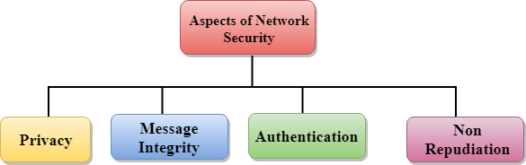

* **Privacy:** Privacy means both the sender and the receiver expects confidentiality. The transmitted message should be sent only to the intended receiver while the message should be opaque for other users. Only the sender and receiver should be able to understand the transmitted message as eavesdroppers can intercept the message. Therefore, there is a requirement to encrypt the message so that the message cannot be intercepted. This aspect of confidentiality is commonly used to achieve secure communication.
* **Message Integrity:** Data integrity means that the data must arrive at the receiver exactly as it was sent. There must be no changes in the data content during transmission, either maliciously or accident, in a transit. As there are more and more monetary exchanges over the internet, data integrity is more crucial. The data integrity must be preserved for secure communication.
* **End-point authentication:** Authentication means that the receiver is sure of the sender?s identity, i.e., no imposter has sent the message.
* **Non-Repudiation:** Non-Repudiation means that the receiver must be able to prove that the received message has come from a specific sender. The sender must not deny sending a message that he or she send. The burden of proving the identity comes on the receiver. For example, if a customer sends a request to transfer the money from one account to another account, then the bank must have a proof that the customer has requested for the transaction.